PRACTICAL NO – 2

1. CREATING ACCOUNT:

STEP 1: Enter all the required details

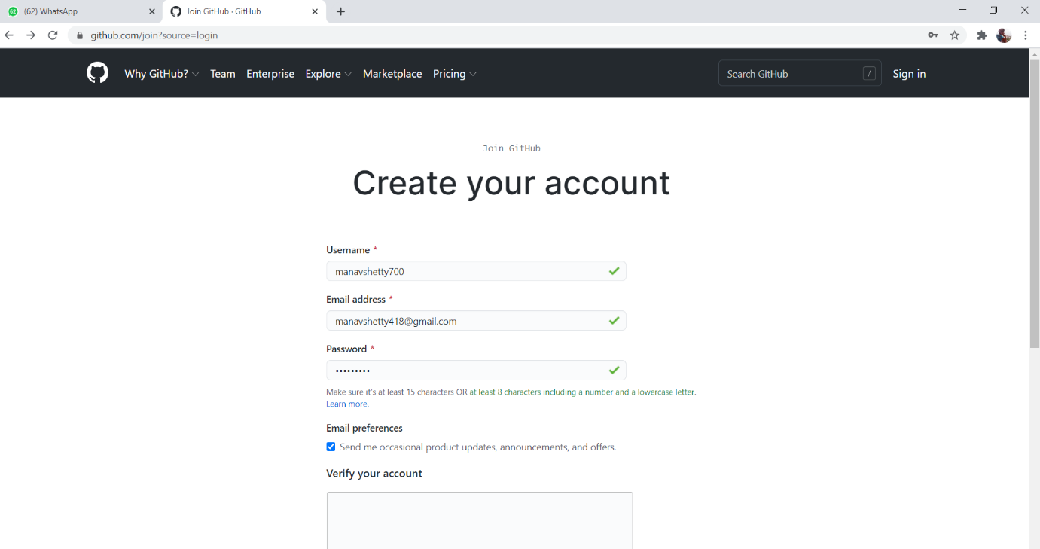

2) STEP 2: Verify the account

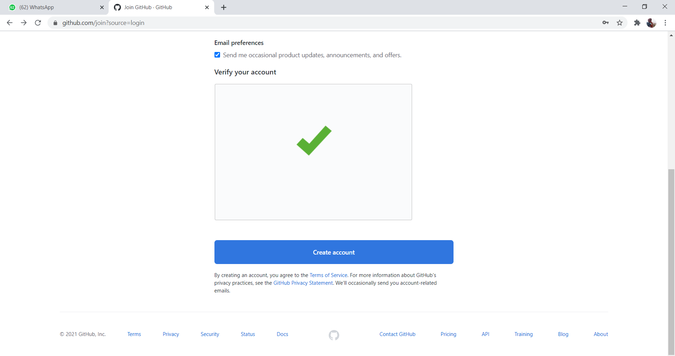

3) STEP 3: verify your email account it will receive a link to join

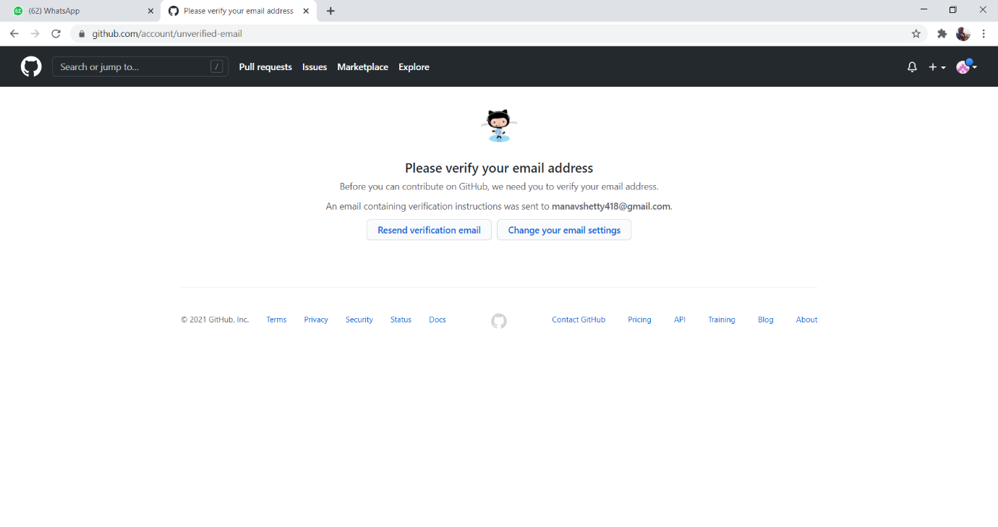

4) STEP 4: The link will be send on the email and click on the link

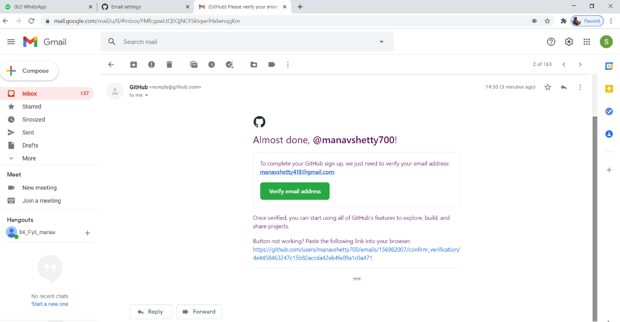

B)CREATING REPOSITORY

1)STEP 1: Click on create repository

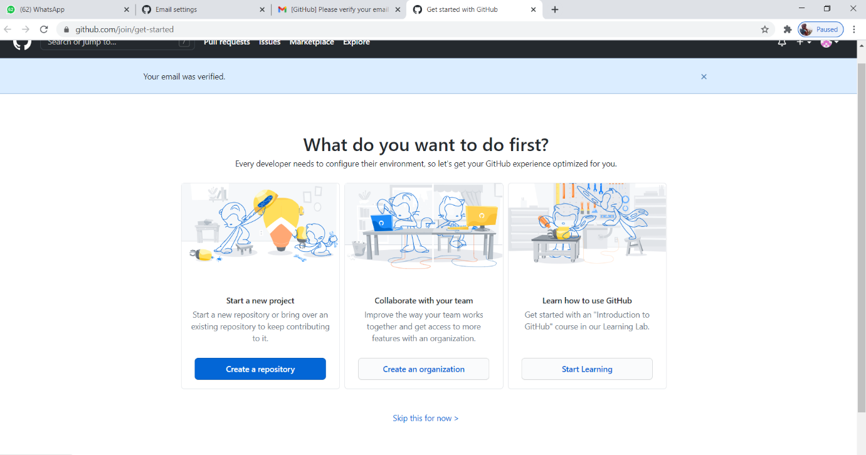

2) STEP 2: Write your repository name and make it to public

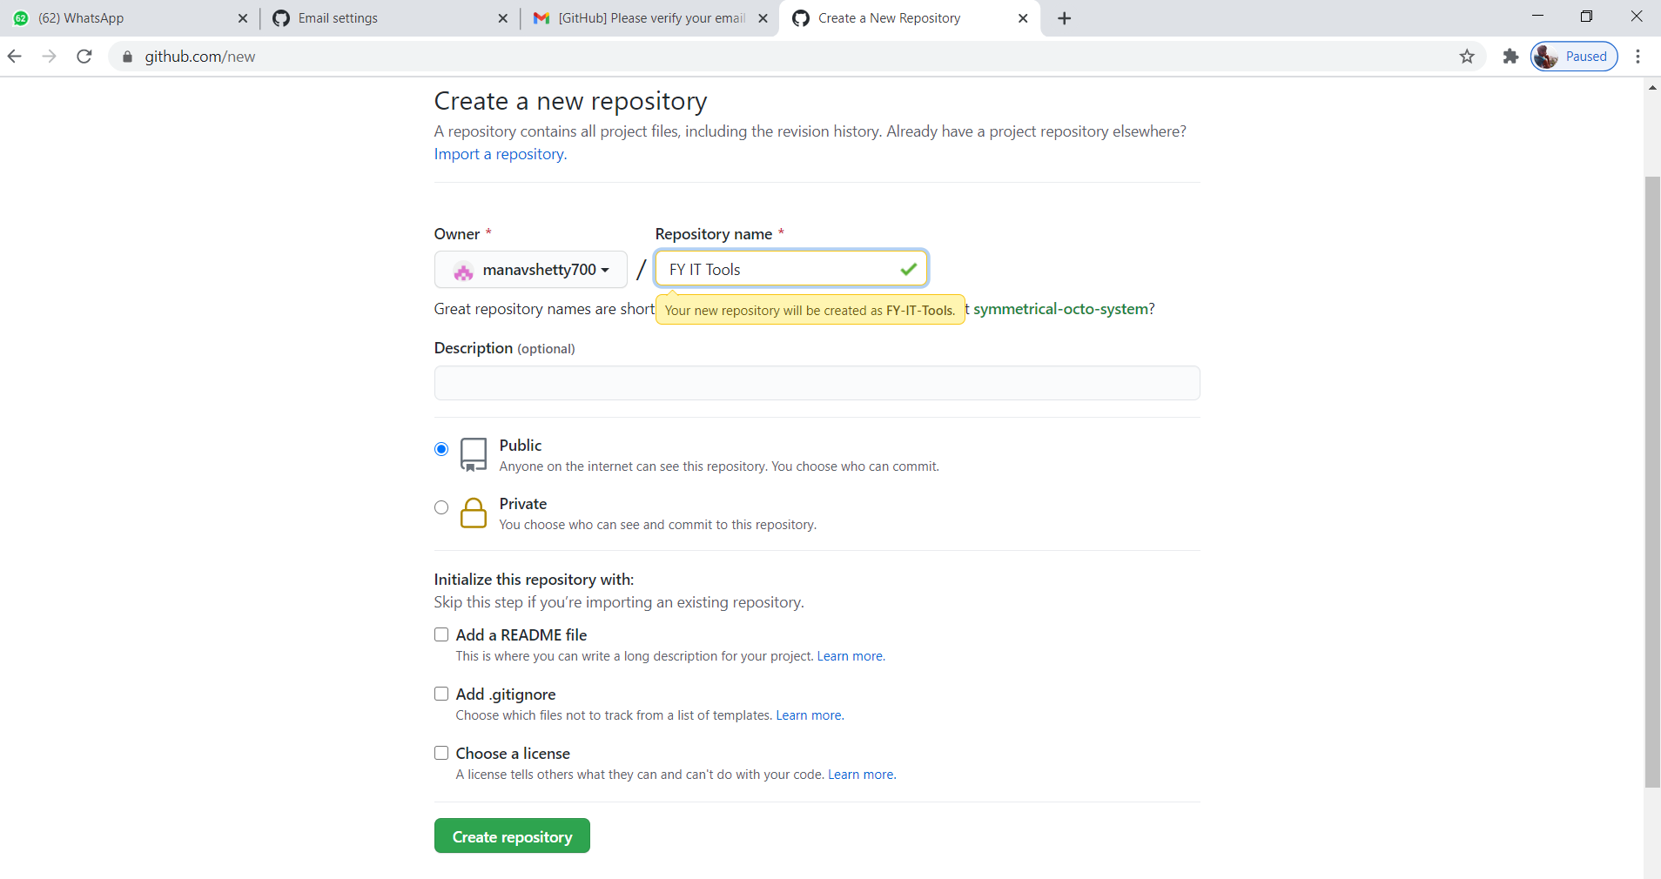

C)CLONING REPOSITORY:

